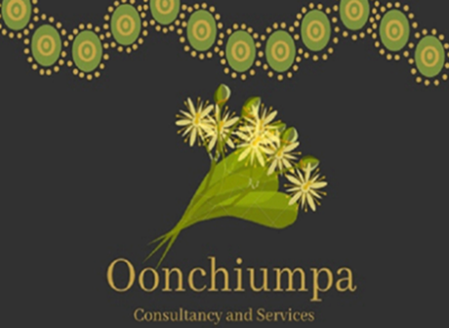

Oonchiumpa Consultancy and Services

24 Parsons Street

Alice Springs NT 0870

Phone: 0474 702 523

Email: [admin@oonchiumpaconsultancy.com.au](mailto:admin@oonchiumpaconsultancy.com.au)

***“Two Cultures, One World, Working Together”***

**Good News Story**

A big thank for Mat and Chloe for giving our young fellas a tour of the McDonald’s store and an opportunity to make their own lunch. This experience made them feel welcomed and they enjoyed making their dessert.

